The goal of the assignment is to create Shareable Content Objects (SCOs) using HTML5 technologies. As part of the exercise, you will be creating three types of question SCOs: A) Math SCO, b) English SCO, and C) Audio/Video SCO.

**Learning Objective**:

* Use of MARK Tag
* Math ML
* Header Tag
* Footer Tag: option
* Data Tag: option
* Video Tag
* Datalist Tag
* Summary Tag

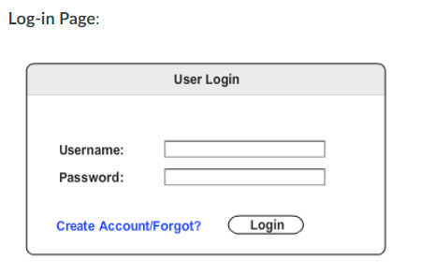

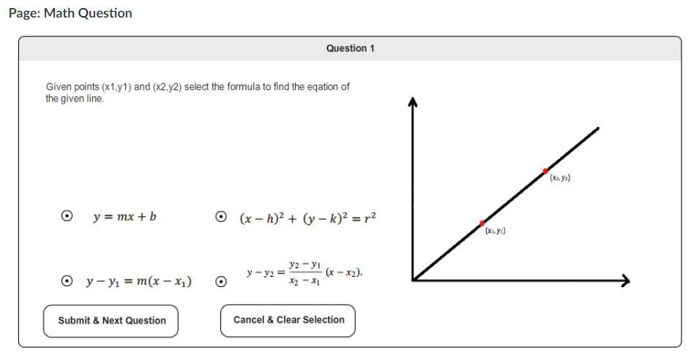

MathML for equations, graph can be png or SVG

